# CloudWatch Logs in API Gateway

## Steps

### Create IAM Role selecting Lambda with APIGateway

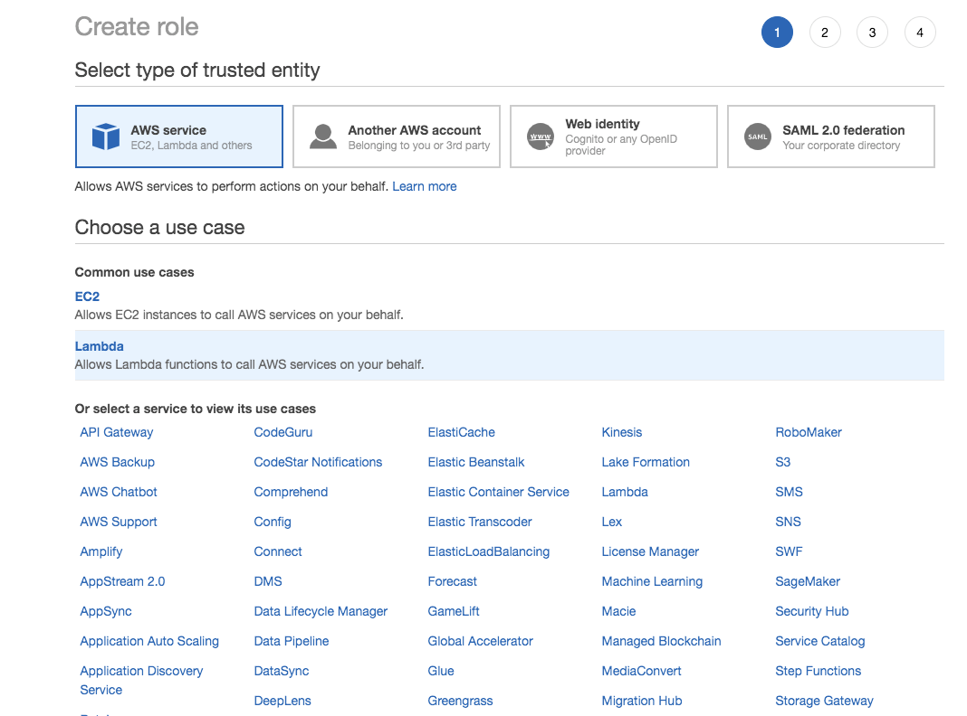

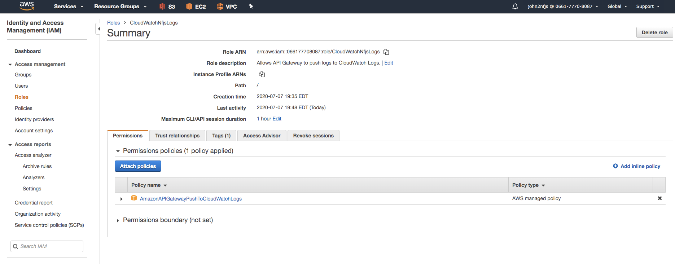

Add tags

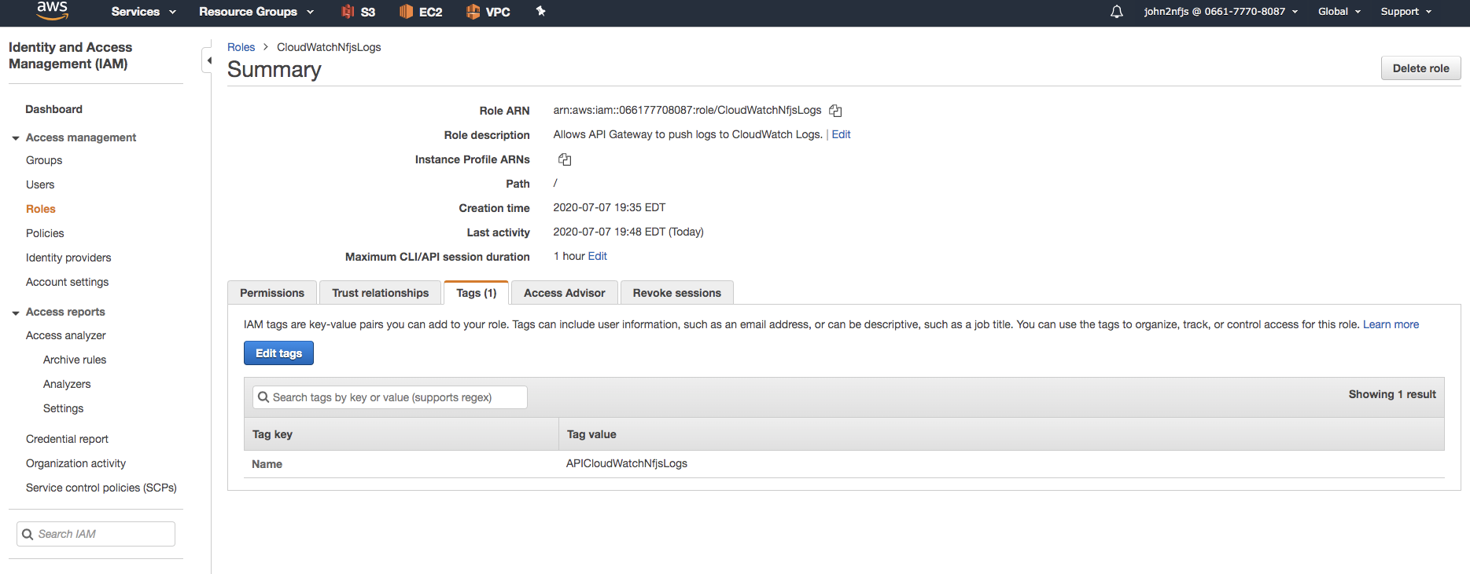

Name: dev.cloudwatch

### Create a method on API Gateway

Select AWS Service

Select AWS Region: us-east-1

Select AWS Service: CloudWatch Logs

Http Method: POST

Action: Enter GetLogsEvent

Execution Role: Add the arn from IAM

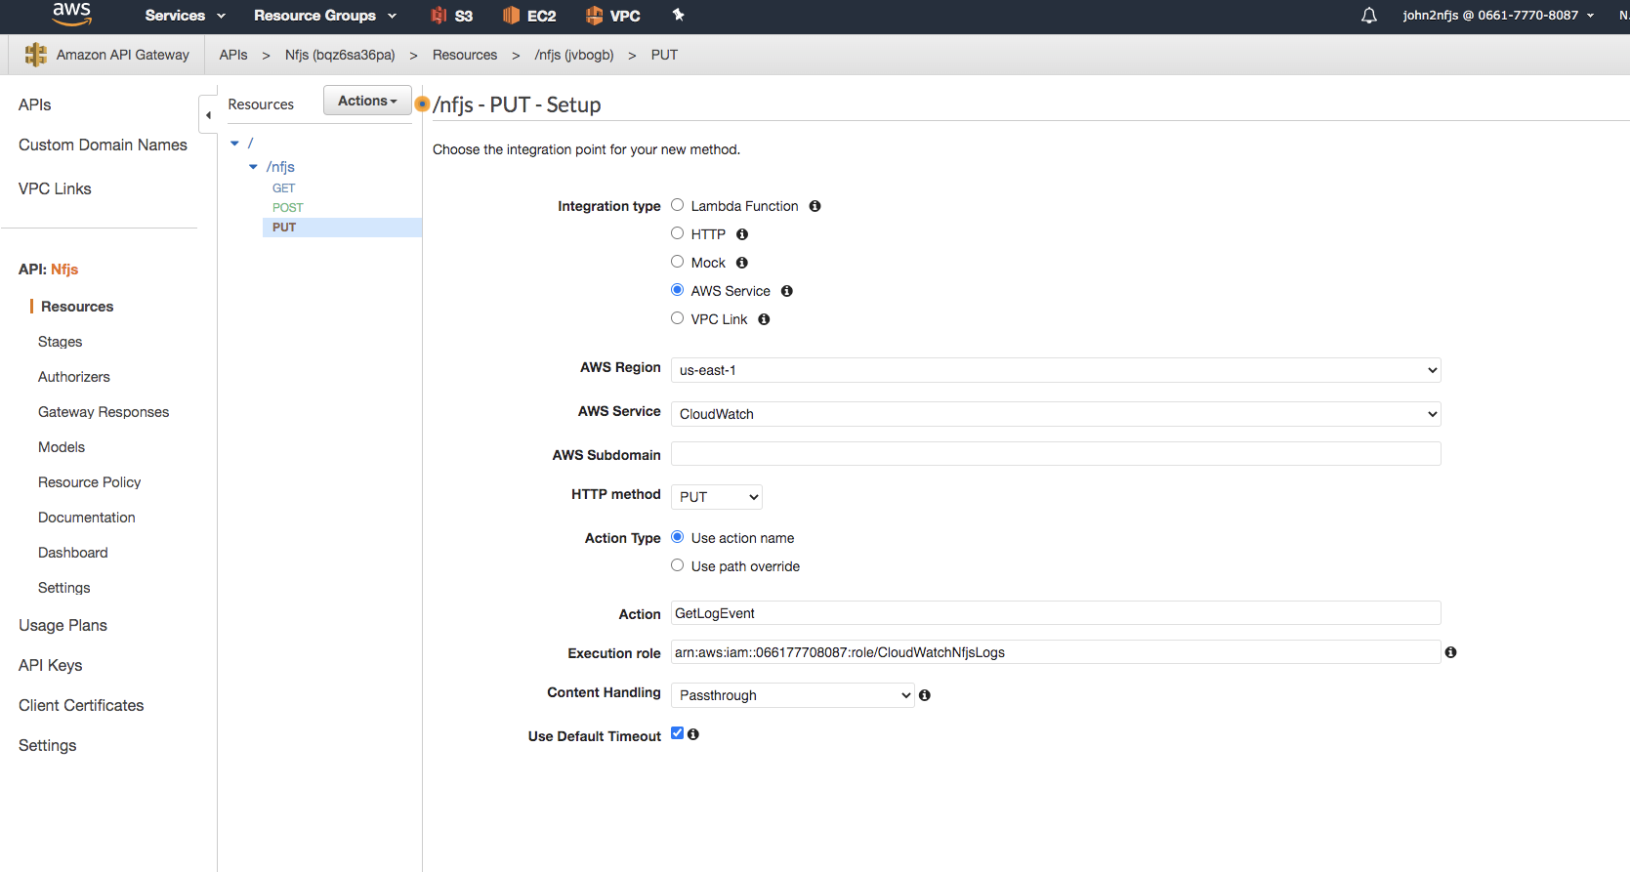

Add also Cloudwatch arn to Settings

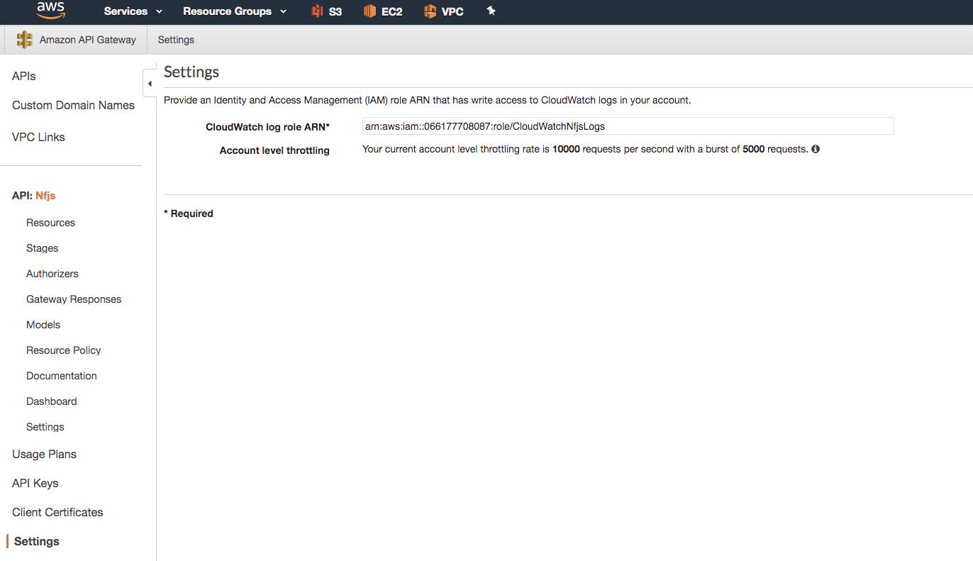

### Deploy the API

Enable the CloudWatch Logs

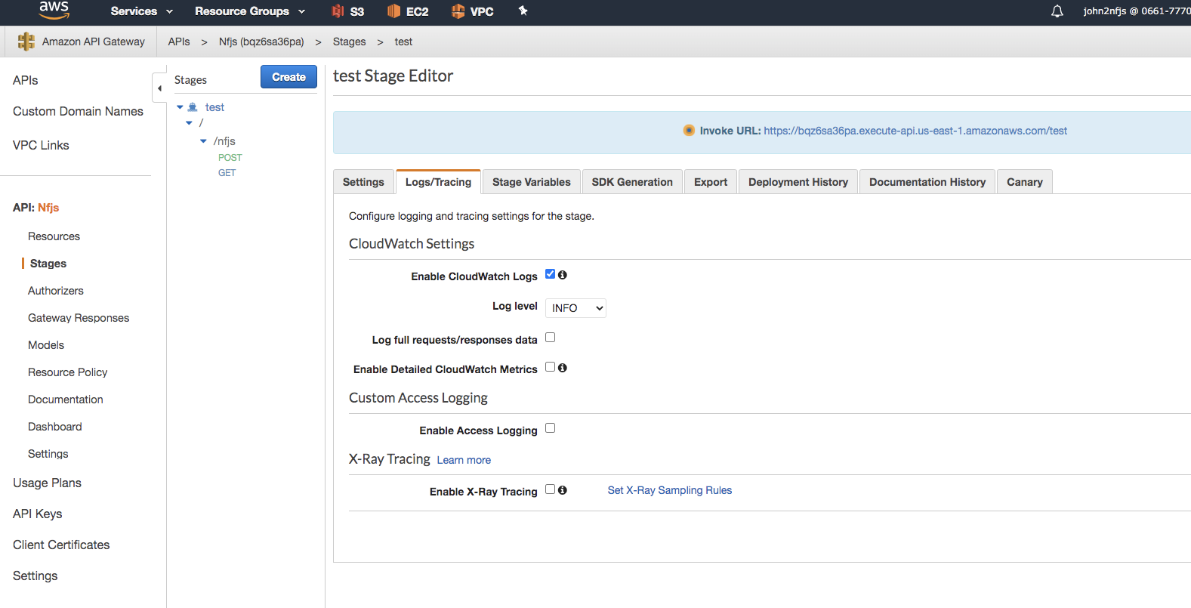

### Cloudwatch Log Groups

